3rd October 2023

2024 Mazda2 Hybrid | more Mazda design features

* With new unique to Mazda styling features the 2024 Mazda2 Hybrid will arrive in the UK in March.
* Line-up in UK will feature Centre-Line, Exclusive-Line, Homura and Homura Plus grades.
* The 2024 Mazda2 Hybrid will continue to be sold alongside the well-established Mazda2.

Arriving in the UK from March 2024, the 2024 Mazda2 Hybrid has a more differentiated design appearance thanks to a new, and unique to Mazda, front bumper and grille design. Designed at Mazda’s European Design Studio in Germany, the revised bumper shape combined with unique rear tailgate garnish gives the 2024 Mazda2 Hybrid a fresh and independent look.

Launched in May 2022, the Mazda2 Hybrid has proven to be a popular addition to Mazda’s line-up in the UK where it sells alongside the established and recently updated Mazda2, ensuring Mazda offers customers a huge choice in the small hatchback market. When it arrives in March next year, the updated 2024 Mazda2 Hybrid will continue to sell alongside the Mazda2, maintaining Mazda’s extensive supermini line-up. UK pricing and full specifications for the 2024 Mazda2 Hybrid will be released at a later date, but it will be offered in four new grades: Centre-Line, Exclusive-Line, Homura and Homura Plus.

Part of Mazda’s electrified line-up that includes the battery electric Mazda MX-30, Mazda CX-60 PHEV and soon to be launched Mazda e-Skyactiv R-EV, the Mazda2 Hybrid brings a self-charging full hybrid powertrain technology to the Mazda model range. Part of the long-standing collaboration between Mazda Motor Corporation and Toyota Motor Corporation, this Toyota Motor Europe OEM supplied model will now feature a more Mazda differentiated exterior design.

Jeremy Thomson, Managing Director Mazda UK said: “the Mazda2 Hybrid is a popular addition to our line-up in the UK and we have good demand for the car in our dealerships and it’s great that from next March it will feature a greater element of Mazda exterior design personality. With the Mazda2 Hybrid sold alongside the recently updated Mazda2, which offers our customers extra individuality with more distinct model grades, increased colour choice and refreshed styling, we are giving customers in the supermini segment the choice of two distinct models, depending on their needs”.

Ends

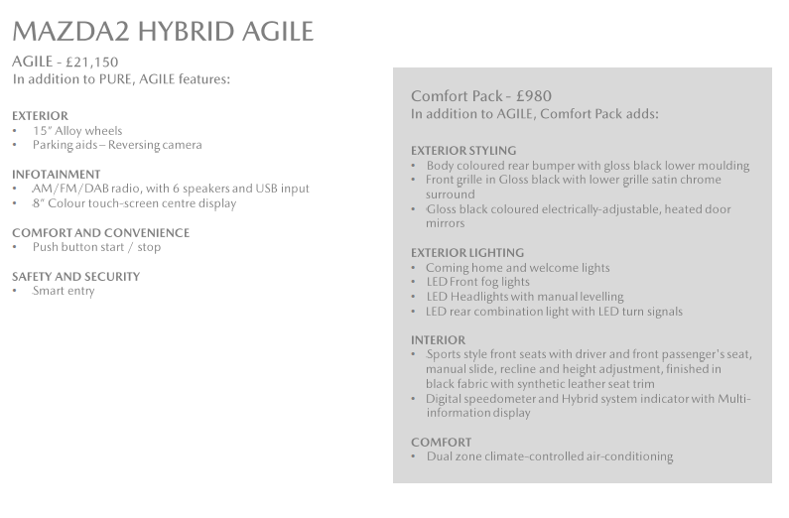

Further press information is available at [www.mazda-press.co.uk](http://www.mazda-press.co.uk)

Interactive Press Packs for all models are available at [www.mazdamediapacks.co.uk](http://www.mazdamediapacks.co.uk)

Visit our media blog at [www.insidemazda.co.uk](http://www.insidemazda.co.uk)

Follow us on Twitter @mazdaukpr

*For further information please contact one of the following:*

Graeme Fudge, PR Director | T: 01322 622 691 | E-mail: [gfudge@mazdaeur.com](mailto:gfudge@mazdaeur.com)

Owen Mildenhall, PR Manager | T: 01322 622 713 | Email: [omildenhall@mazdaeur.com](mailto:omildenhall@mazdaeur.com)

Monique Clarke, Press Officer | T: 01322 622 650 | Email: [mclarke@mazdaeur.com](mailto:mclarke@mazdaeur.com)

Martine Varrall, Press Officer | T: 01322 622 776 | Email: [mvarrall@mazdaeur.com](mailto:mvarrall@mazdaeur.com)

Ref: 231003FINAL