10th January 2024

2024 Mazda2 Hybrid | UK price and specification announced

* With new unique to Mazda styling features the 2024 Mazda2 Hybrid will arrive in the UK in March.
* Line-up in UK will feature Centre-Line, Exclusive-Line, Homura and Homura Plus grades.
* The 2024 Mazda2 Hybrid will continue to be sold alongside the well-established Mazda2.

Arriving in the UK from March, the 2024 Mazda2 Hybrid has a more differentiated design appearance thanks to a new, and unique to Mazda, front bumper and grille design. Designed at Mazda’s European Design Studio in Germany, the revised bumper shape combined with unique rear tailgate garnish gives the 2024 Mazda2 Hybrid a fresh and independent look.

Launched in May 2022, the Mazda2 Hybrid has proven to be a popular addition to Mazda’s line-up in the UK where it sells alongside the established and recently updated Mazda2, ensuring Mazda offers customers a huge choice in the small hatchback market. The updated 2024 Mazda2 Hybrid will continue to sell alongside the Mazda2, maintaining Mazda’s extensive supermini line-up.

In the UK, the 2024 Mazda2 Hybrid will be available in four new grades: Centre-Line, Exclusive-Line, Homura and Homura Plus – priced from £24,130 to £29,230. Alongside, the Mazda specific updates to the exterior design, the 2024 Mazda2 Hybrid features connectivity and entertainment upgrades across the range, including wireless Apple CarPlay and Android Auto, plus a new colour touch screen central display.

Exclusive-Line models and upwards feature new equipment that includes auto-folding mirrors, Blind-Spot Monitoring, plus front and rear parking sensors, while at the top of the range the Homura and Homura Plus grades feature a new digital instrument binnacle and black roof lining. Exclusive to Homura Plus grade, the 2024 Mazda2 Hybrid also features integrated navigation and a panoramic glass roof.

Part of Mazda’s electrified line-up that includes the battery electric Mazda MX-30, Mazda CX-60 PHEV and Mazda MX-30 e-Skyactiv R-EV PHEV - the Mazda2 Hybrid brings a self-charging full hybrid powertrain technology to the Mazda model range. Part of the long-standing collaboration between Mazda Motor Corporation and Toyota Motor Corporation, this Toyota Motor Europe OEM supplied model will now feature a more Mazda differentiated exterior design but retains an unchanged drivetrain.

With a combined power output of 116ps driven via a CVT automatic transmission, the 2024 Mazda2 Hybrid will accelerate from 0-62mph in 9.7 seconds and returns a WLTP combined cycle fuel economy of between 67.3 to 74.3mpg and CO2 emissions of just 87-98g/km depending on the specification of 16” or 15” wheels.

At start-up the 2024 Mazda2 Hybrid automatically runs in EV mode, offering smooth, seamless and quiet running on electric motor power in urban environments, with zero CO2, NOx and particulate emissions. During normal driving, power allocation is adjusted between the petrol engine and electric motor for optimum performance and the best possible fuel efficiency. During deceleration and under braking, kinetic energy is recovered as electrical energy for storage in the high-performance battery.

Battery power level is constantly managed via an engine-driven generator to remove any need to recharge the system from an external source. Although it is a compact B-segment vehicle, the new Mazda2 Hybrid’s long 2,560 mm wheelbase offers comfortable accommodation for up to four adults, as well as 286 litres of boot space.

Jeremy Thomson, Managing Director Mazda UK said: “the Mazda2 Hybrid has proved to be a popular addition to our line-up in the UK, so it’s great that we now have a car with a greater element of Mazda exterior design personality. With the 2024 Mazda2 Hybrid sold alongside the recently updated Mazda2, we are giving customers in the supermini segment the choice of two distinct models, depending on their needs, ensuring Mazda has the widest customer offering in a sector that has seen several key models disappear in recent months.”

Ends

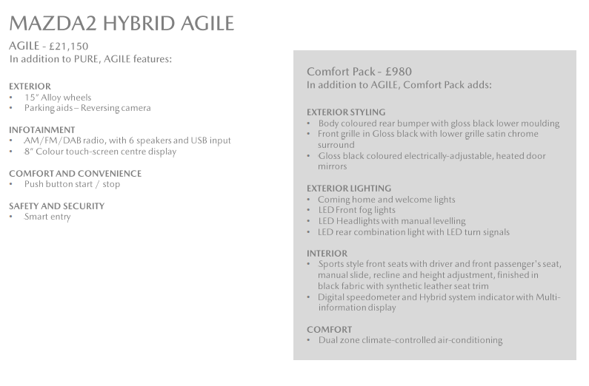

Further press information is available at [www.mazda-press.co.uk](http://www.mazda-press.co.uk)

Interactive Press Packs for all models are available at [www.mazdamediapacks.co.uk](http://www.mazdamediapacks.co.uk)

Visit our media blog at [www.insidemazda.co.uk](http://www.insidemazda.co.uk)

Follow us on Twitter @mazdaukpr

*For further information please contact one of the following:*

Graeme Fudge, PR Director | T: 01322 622 691 | E-mail: [gfudge@mazdaeur.com](mailto:gfudge@mazdaeur.com)

Owen Mildenhall, PR Manager | T: 01322 622 713 | Email: [omildenhall@mazdaeur.com](mailto:omildenhall@mazdaeur.com)

Monique Clarke, Press Officer | T: 01322 622 650 | Email: [mclarke@mazdaeur.com](mailto:mclarke@mazdaeur.com)

Martine Varrall, Press Officer | T: 01322 622 776 | Email: [mvarrall@mazdaeur.com](mailto:mvarrall@mazdaeur.com)

Ref: 240110FINAL